LTSpice Circuit Schematic:

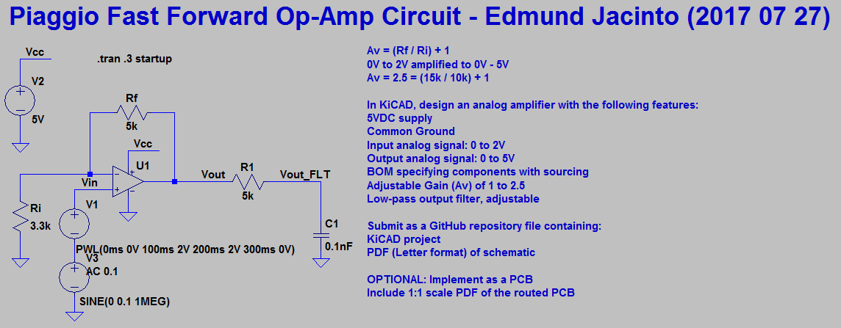

Results (Blue = Vin 0V to 2V + 100mV at 1MHz, Green = Vout = Vin * Av of 2.5, Red = Vout_Filtered)

